4.1 Joint estimation of β₀ and β₁

Suppose separate 95% confidence intervals are constructed for β₀ and β₁. What is the confidence level that BOTH confidence interval inferences are correct?

NOT 95%!

If these inferences were independent, then the probability of both being correct is 0.95²=0.9025. However, they are not independent, which makes the actual confidence level difficult to calculate.

Family and statement (individual) confidence coefficients

A set of estimates or hypothesis tests of interest are called a “family”.

If we are interested in inferences for β₀ and β₁ simultaneously, then they form a family.

Each individual estimate or hypothesis test has a confidence level associated with it.

For example, a 95% confidence interval for β₁.

The family confidence level corresponds to the level of confidence that all inferences are correct for the entire family.

For example, a C% confidence level that both β₀ and β₁ are within their confidence interval limits.

Bonferroni joint confidence intervals

Find an expression for the probability that both confidence intervals contain their corresponding parameters; i.e., find the family confidence level.

Let A₁ = the event that β₀ is not in the C.I.
Let A₂ = the event that β₁ is not in the C.I.

The probability that at least one confidence interval does not contain β_{i} is P(A₁ or A₂) = P(A₁ ∪ A₂). At least one means that A₁ is true or A₂ is true or A₁ and A₂ are true.

The probability that BOTH confidence intervals contain their corresponding parameters is 1-P(A₁ ∪ A₂) (use the complement).

From the addition theorem of probability (p. 662 of KNN),

P(A₁ ∪ A₂) = P(A₁) + P(A₂) – P(A₁ ∩ A₂)

where P(A₁ ∩ A₂) = P(A₁ and A₂) = probability both confidence intervals do NOT contain their corresponding parameters.

Thus, 1 - P(A₁ ∪ A₂) = 1 - P(A₁) - P(A₂) + P(A₁ ∩ A₂)
⇒ 1 - P(A₁ ∪ A₂) ≥ 1 - P(A₁) - P(A₂)

In words: The probability that both confidence intervals contain their corresponding parameters is greater than or equal to 1 minus the probability β₀ is not in its confidence interval minus the probability β₁ is not in its confidence interval.

For a (1-α)100% confidence interval, P(A_{i})=α for i=1,2.

If 95% confidence intervals are formed for β₀ and β₁, then the probability that both intervals contain their corresponding parameters is ≥ 1 – 0.05 – 0.05 = 0.90.

Suppose a family confidence level of at least 95% is desired. Then using 97.5% confidence intervals for each gives the desired level.

In general for a “Bonferroni” family confidence level of at least (1-α)100%, the confidence levels for each of 2 C.I. are 1-α/2. This is because 1-P(A₁ ∪ A₂) ≥ 1 - P(A₁) - P(A₂) = 1 - α/2 - α/2 = 1-α. The C.I.s for β₀ and β₁ are:

For β₀: 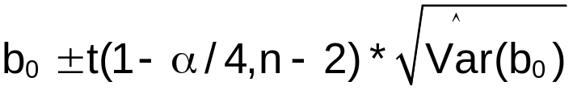
For β₁: 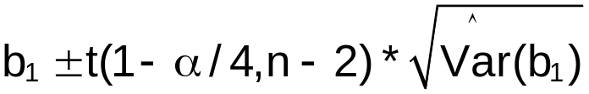

Example: HS and College GPA (HS_college_GPA_ch4.R)

Find C.I.s for β₀ and β₁ using a family confidence level of 95%.

> #Read in the data
> gpa<-read.table(file =
"C:\\chris\\UNL\\STAT870\\Chapter1\\gpa.txt",
header=TRUE, sep = "")
> head(gpa)
HS.GPA College.GPA
1 3.04 3.1
2 2.35 2.3
3 2.70 3.0
4 2.05 1.9
5 2.83 2.5
6 4.32 3.7

> mod.fit<-lm(formula = College.GPA ~ HS.GPA, data = gpa)
> sum.fit<-summary(mod.fit)
> sum.fit$coefficients
Estimate Std. Error t value Pr(>|t|)
(Intercept) 0.7075776 0.19941429 3.548279 2.296706e-03
HS.GPA 0.6996584 0.07319166 9.559264 1.778933e-08

> alpha<-0.05
> g<-2
> qt(p = 1-alpha/(2*g), df = mod.fit$df.residual)
[1] 2.445006
For β₀:
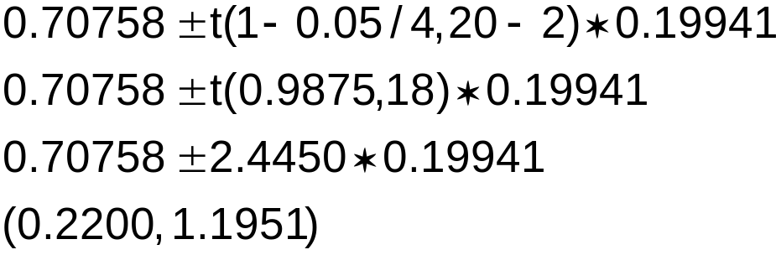
For β₁:
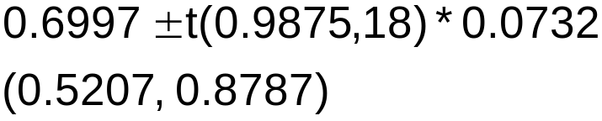

We are at least 95% confident that β₀ is between 0.2200 and 1.1951 and β₁ is between 0.5207 and 0.8787.

More R code and output:

> mod.fit$coefficients[1]-qt(p = c(1-alpha/(2*g),
alpha/(2*g)), df = mod.fit$df.residual)
*sum.fit$coefficients[1,2]
[1] 0.2200086 1.1951467

> mod.fit$coefficients[2]-qt(p = c(1-alpha/(2*g),
alpha/(2*g)), df = mod.fit$df.residual)
*sum.fit$coefficients[2,2]
[1] 0.5207044 0.8786124

> #Another way
> confint(object = mod.fit, level = 1 - alpha/g)
1.25 % 98.75 %
(Intercept) 0.2200086 1.1951467
HS.GPA 0.5207044 0.8786124

Notes:
- The Bonferroni (1-α)100% family confidence level is a lower bound. The actual family confidence level may be higher.
- This procedure of finding a lower bound can be extended to g simultaneous confidence intervals. Instead of using 1-α for the individual confidence levels, 1-α/g is used to assure at least a (1-α)100% family confidence level. Thus, 1-α/(2g) needs to be used when finding the t-distribution quantile because a two-sided confidence interval is being found.
- It is best to use this procedure when g is small. If g is large, the individual confidence levels become close to 1 which causes the confidence intervals to be very wide.

4.2 Simultaneous estimation of mean responses

Remember that E(Y_{h}) is the mean value of Y_{h} at a specific X_{h}. The (1-α)100% C.I. for E(Y_{h}) at X_{h} is (from Section 2.4):
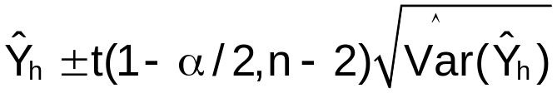
where 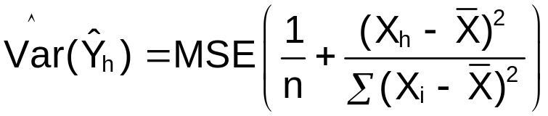

Suppose we wanted to find C.I.s for E(Y_{h}) at many different X_{h} values with a family confidence level of 1-α.

Bonferroni procedure

To have a family confidence level of at least 1-α, the Bonferroni confidence limits are:

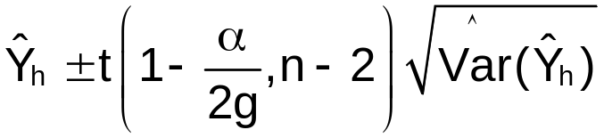

where g is the number of C.I.s in the family.

Example: College and HS GPA (HS_college_GPA_ch4.R)

Find C.I.s for E(Y_{h}) at X_{h}=2.0, 2.5, 3.0, 3.5, 4.0 with at least a 95% family confidence level.

> more.gpa<-data.frame(HS.GPA = c(2, 2.5, 3, 3.5, 4))
> g<-nrow(more.gpa)
> round(predict(object = mod.fit, newdata = more.gpa,
interval = "confidence", level = 1-alpha/g), 2)
fit lwr upr
1 2.11 1.88 2.33
2 2.46 2.26 2.65
3 2.81 2.59 3.02
4 3.16 2.88 3.43
5 3.51 3.15 3.86

Note the confidence level used for each individual confidence interval above (1 – α/g = 1 – 0.05/5 = 0.99).

4.3 Simultaneous prediction intervals for a new observation

Suppose we want to estimate (or predict) the random variable, Y_{h}. Remember that Y_{h(new)} is the notation of KNN to denote this value.

The (1-α)100% P.I. for Y_{h(new)} at X_{h} is (from Section 2.5):

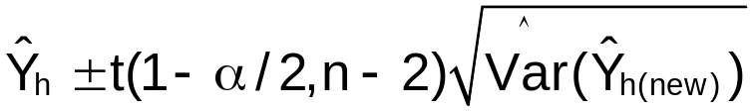
where 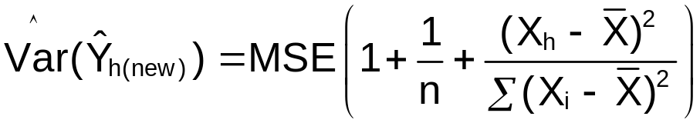

Suppose we wanted to find P.I.s for Y_{h(new)} at many different X_{h} values with a family confidence level of 1-α.

Bonferroni procedure

To have a family confidence level of at least 1-α, the Bonferroni confidence limits are:

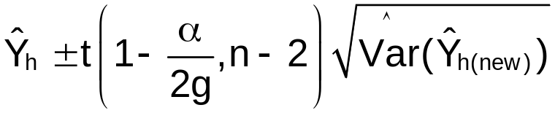
where g is the number of P.I.s in the family.

Example: College and HS GPA (HS_college_GPA_ch4.R)

Continuing the example from Section 4.2,
> round(predict(object = mod.fit, newdata = more.gpa,
interval = "prediction", level = 1-alpha/g),2)
fit lwr upr
1 2.11 1.22 2.99
2 2.46 1.58 3.33
3 2.81 1.93 3.69
4 3.16 2.26 4.05
5 3.51 2.58 4.43

Question: In Chapter 2, we found confidence and prediction interval bands for all E(Y) and Y within the appropriate range for X values.
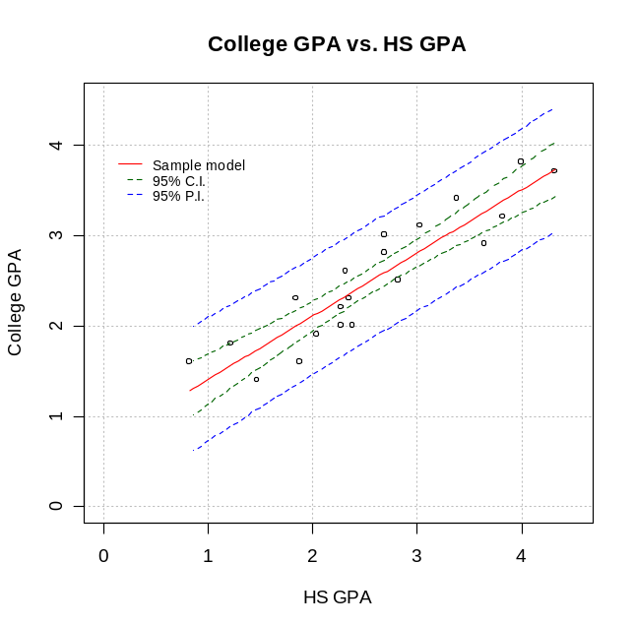

Suppose we want to use the Bonferroni procedure here. What should g be?

4.4 Regression through the origin

Sometimes it may be known that when X is 0 Y must also be 0. In this case, the population regression model may be taken to be Y_{i}=β₁X_{i}+ε_{i}. This changes the least squares estimate for β₁, MSE, and other estimates (see p. 162). To use the lm() function in R, simply use “y ~ x – 1” or “y ~ 0 + x” in the formula option. Most often, it is NOT known that the model goes through (0,0). Therefore, it is safer to just leave β₀ is the model. If β₀ is truly 0, then b₀ should be close to 0 (differing only by sampling variability).

4.5 Effects of measurement errors

The response and predictor variables may have errors in their recorded values.

For example, suppose football players are timed with a stopwatch in the 40-yard dash. Most likely the time recorded is not exactly correct (human error).

If there are measurement errors for the response variable, these are absorbed by the model error term ε.

If there are measurement errors in the predictor variable, this generally causes problems with using the regression analysis methods discussed in this class. See Fuller (1987) for one reference on the subject.

4.6 Inverse Prediction

Use the regression model to make a prediction about X.

Suppose a new Y observation becomes available, Y_{h(new)}, and we want to predict the corresponding X_{h(new)} value. This is like going in the opposite direction from what we have been doing all semester!

Since the sample regression model is 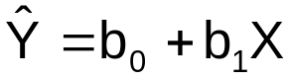, we can rewrite this as 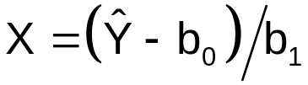 provided 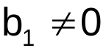. Since Y_{h(new)} is known and we want to predict X, the above can be rewritten as:
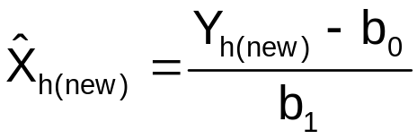
The true value of X for Y_{h(new)} is denoted by X_{h(new)}.

The approximate (1-α)100% C.I. for X_{h(new)} is:

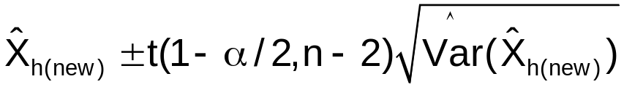
where 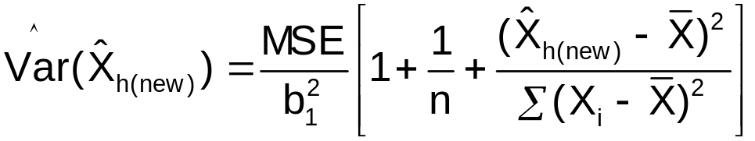

Inverse prediction is often used to calibrate a measurement taking instrument.

Example: Calibrate a thermometer (calibrate.R)

Suppose a thermometer is being calibrated to determine if it is reliable enough for a physician to use with patients. It is placed in a water bath at a known constant temperature X, and the corresponding temperature reading Y is recorded. Below are the data:

Y | X
95.71 | 96
98.16 | 98
99.52 | 100
102.09 | 102
103.79 | 104
106.18 | 106
108.14 | 108
110.21 | 110

The thermometer is later used to measure the temperature of a patient. Suppose the temperature reading is Y_{h(new)}=104. Find a 95% C.I. for X_{h(new)}.

> #One way to enter the data into R
> set1<-data.frame(Y = c(95.71, 98.16, 99.52, 102.09,
103.79, 106.18, 108.14, 110.21),
X = c(96, 98, 100, 102,
104, 106, 108, 110))
> set1
Y X
1 95.71 96
2 98.16 98
3 99.52 100
4 102.09 102
5 103.79 104
6 106.18 106
7 108.14 108
8 110.21 110

> mod.fit<-lm(formula = Y ~ X, data = set1)
> sum.fit<-summary(mod.fit)
> sum.fit

Call:
lm(formula = Y ~ X, data = set1)

Residuals:
Min 1Q Median 3Q Max
-0.36429 -0.09381 0.01857 0.12202 0.33619

Coefficients:
Estimate Std. Error t value Pr(>|t|)
(Intercept) -3.13952 1.86490 -1.683 0.143
X 1.03024 0.01809 56.957 1.97e-09 ***
---
Signif. codes: 0 '***' 0.001 '**' 0.01 '*' 0.05 '.' 0.1 ' ' 1

Residual standard error: 0.2344 on 6 degrees of freedom
Multiple R-Squared: 0.9982, Adjusted R-squared: 0.9978
F-statistic: 3244 on 1 and 6 DF, p-value: 1.967e-09

The sample regression model is 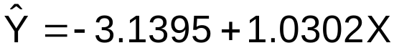

> Y.new<-104
> alpha<-0.05
> n<-nrow(set1)
> X.hat.new<-(Y.new - mod.fit$coefficients[1]) /
mod.fit$coefficients[2]
> as.numeric(X.hat.new)
[1] 103.9949

> sum.sq<-var(set1$X)*(n-1)
> var.X.hat.new<-sum.fit$sigma^2 /
mod.fit$coefficients[2]^2 * (1 + 1/n + (X.hat.new –
mean(set1$X))^2/sum.sq)
> save.ci<-X.hat.new-qt(p = c(1-alpha/2,alpha/2), df =
mod.fit$df.residual)*sqrt(var.X.hat.new)
> round(save.ci,2)
[1] 103.40 104.59

The 95% C.I. for X_{h(new)} is (103.40, 104.59).

> #pty = "s": Use square plot here since both variables are
measured on the same scale - "m" is default
> #xaxs and yaxs = "i" forces the x and y-axes to be
exactly within the given range - "r" is default
> par(pty = "s", xaxs = "i", yaxs = "i")
> plot(x = set1$X, y = set1$Y, xlab = "Water bath
temperature (X)", ylab = "Thermometer temperature
(Y)", main = "Thermometer temperature vs. Water bath
temperature", panel.first = grid(col = "gray", lty =
"dotted"), xlim = c(95, 112), ylim = c(95, 112))
> #Add tick marks without labels, side = 1 is x-axis, tcl
is length of tick mark
> axis(side = 1, at = seq(from = 95, to = 112, by = 1),
labels = FALSE, tcl = -0.25)
> #Add tick marks without labels, side = 2 is y-axis
> axis(side = 2, at = seq(from = 95, to = 112, by = 1),
labels = FALSE, tcl = -0.25)
> curve(expr = mod.fit$coefficients[1] +
mod.fit$coefficients[2]*x, col = "red", lty =
"solid", lwd = 1, add = TRUE, xlim = c(min(set1$X),
max(set1$X)))
> segments(x0 = 0, y0 = Y.new, x1 = X.hat.new, y1 = Y.new,
col = "darkgreen", lty = "dashed", lwd = 2)
> segments(x0 = X.hat.new, y0 = Y.new, x1 = X.hat.new, y1 =
0, col = "darkgreen", lty = "dashed", lwd = 2)
> points(x = save.ci, y = c(95.1, 95.1), pch = c("(", ")"),
col = "darkgreen") #Plot C.I.

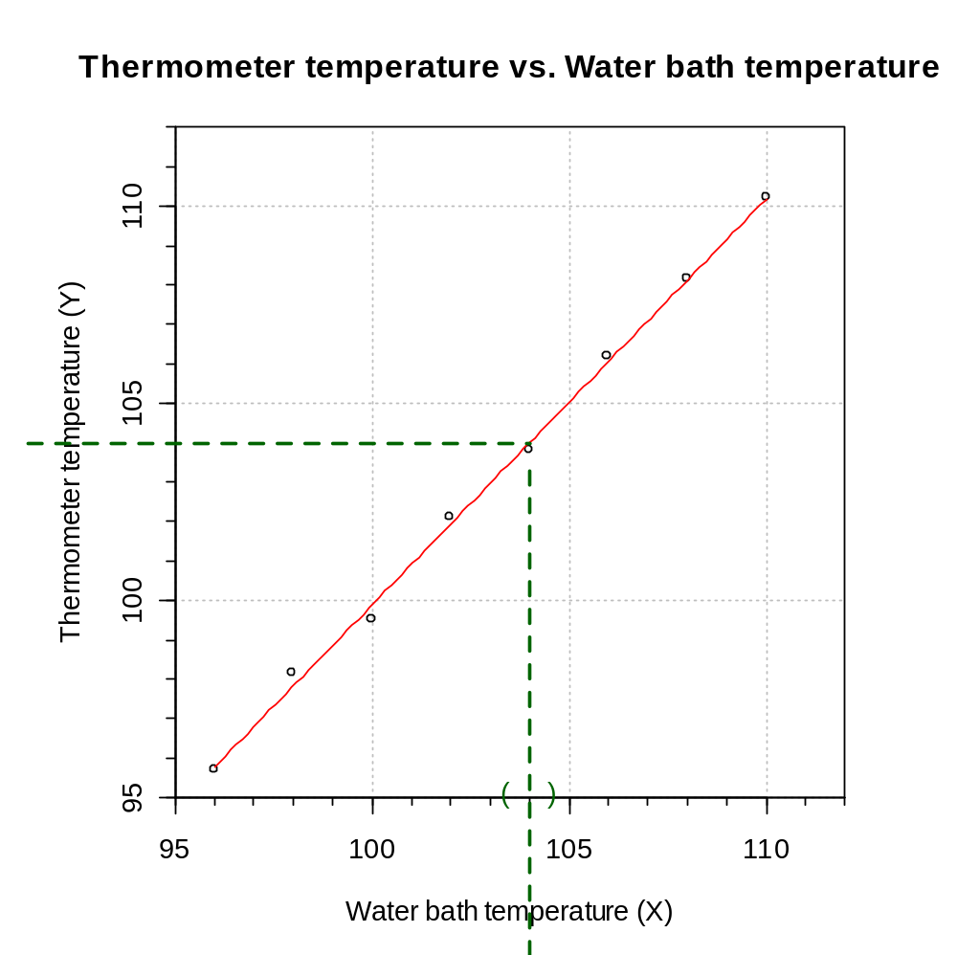

4.7 Choice of X levels

Read on your own.

